# MySQL Exam Royal United Kingsman – Bank

Royal United Kingsman Bank or most widely known as R.U.K. Bank is a new bank founded by Darkman Nakov. You have been employed by the bank to design a database prototype, which will lay the foundation for the main database. You will need to prove your skills in database definition, data manipulation and extraction and database programmability.

## Section 0: Database Overview

You have been given an Entity / Relationship Diagram of the Database:

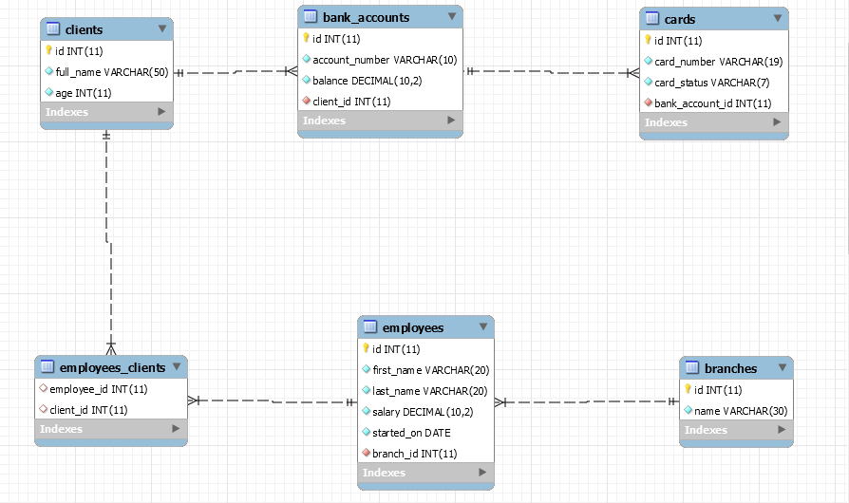

The **Bank's Database** needs to hold information about **branches**, **employees**, **clients**, **bank accounts**, **cards**.

Your task is to create a database called ruk_database. Then you will have to create several **tables**.

* branches – contains information about the **branches**.
* employees – contains information about the **employees**.
  + Each employee has a branch.
* clients – contains information about the **clients**.
* employees_clients – a **many** to **many** **mapping** table between the **employees** and the **clients**.
* bank_accounts – contains information about the **bank accounts**.
  + Each bank_account has a client.
* cards – contains information about the **cards**.
  + Each card has a client.
  + Each card has a bank_account.

## Section 1: Data Definition Language (DDL) – 40 pts

Make sure you implement the whole database correctly on your local machine, so that you could work with it.

The instructions you'll be given will be the minimal needed for you to implement the database.

### Table Design

You have been tasked to create the tables in the database by the following models:

**branches**

|  |  |  |
| --- | --- | --- |
| **Column Name** | **Data Type** | **Constraints** |
| id | **Integer,** from **1** to **2,147,483,647.** | **Primary Key AUTO_INCREMENT** |
| name | A **string** containing a maximum of **30 characters**. Unicode is **NOT** needed. | **NULL** is **NOT** permitted**. UNIQUE** values. |

**employees**

|  |  |  |
| --- | --- | --- |
| **Column Name** | **Data Type** | **Constraints** |
| id | **Integer,** from **1** to **2,147,483,647.** | **Primary Key AUTO_INCREMENT** |
| first_name | A **string** containing a maximum of **20 characters**. Unicode is **NOT** needed. | **NULL** is **NOT** permitted**.** |
| last_name | A **string** containing a maximum of **20 characters**. Unicode is **NOT** needed. | **NULL** is **NOT** permitted**.** |
| salary | **DECIMAL**, up to **10 digits**, **2** of which after the **decimal point**. | **NULL** is **NOT** permitted**.** |
| started_on | A **DATE** field. Format - (**YYYY-MM-DD**). | **NULL** is **NOT** permitted**.** |
| branch_id | **Integer,** from **1** to **2,147,483,647.** | Relationship with table branches.  **NULL** is **NOT** permitted**.** |

**clients**

|  |  |  |
| --- | --- | --- |
| **Column Name** | **Data Type** | **Constraints** |
| id | **Integer,** from **1** to **2,147,483,647.** | **Primary Key AUTO_INCREMENT** |
| full_name | A **string** containing a maximum of **50 characters**. Unicode is **NOT** needed. | **NULL** is **NOT** permitted**.** |
| age | **Integer,** from **1** to **2,147,483,647.** | **NULL** is **NOT** permitted**.** |

**employees_clients**

|  |  |  |
| --- | --- | --- |
| **Column Name** | **Data Type** | **Constraints** |
| employee_id | **Integer**, from **1** to **2,147,483,647.** | Relationship with table employees. |
| client_id | **Integer**, from **1** to **2,147,483,647.** | Relationship with table clients. |

**bank_accounts**

|  |  |  |
| --- | --- | --- |
| **Column Name** | **Data Type** | **Constraints** |
| id | **Integer**, from **1** to **2,147,483,647.** | **Primary Key AUTO_INCREMENT** |
| account_number | A **string** containing a maximum of **10 characters**. Unicode is **NOT** needed. | **NULL** is **NOT** permitted. |
| balance | **DECIMAL**, up to **10 digits**, **2** of which after the **decimal point**. | **NULL** is **NOT** permitted**.** |
| client_id | **Integer**, from **1** to **2,147,483,647.** | Relationship with table clients.  **NULL** is **NOT** permitted**.**  **UNIQUE** values. |

**cards**

|  |  |  |
| --- | --- | --- |
| **Column Name** | **Data Type** | **Constraints** |
| id | **Integer**, from **1** to **2,147,483,647.** | **Primary Key AUTO_INCREMENT** |
| card_number | A **string** containing a maximum of **19 characters**. Unicode is **NOT** needed. | **NULL** is **NOT** permitted. |
| card_status | A **string** containing a maximum of **7 characters**. Unicode is **NOT** needed. | **NULL** is **NOT** permitted. |
| bank_account_id | **Integer**, from **1** to **2,147,483,647.** | Relationship with table bank_accounts.  **NULL** is **NOT** permitted**.** |

Submit your solutions in Judge on the first task. Submit **all** SQL table creation statements.

You will also be given a data.sql file. It will contain a **dataset** with random data which you will need to **store** in your **local database**. This data will be given to you so you will not have to think of data and lose essential time in the process. The data is in the form of **INSERT** statement queries.

## Section 2: Data Manipulation Language (DML) – 30 pts

Here we need to do several manipulations in the database, like changing data, adding data etc.

### Insert

You will have to **insert** records of data into the **cards** table, based on the **clients** table.

For clients with id between **191** and **200** (**inclusive**), **insert data** in the cards table with the **following values**:

* card_number –set it to **full name** of the **client**, but **reversed**!
* card_status – set it to "Active".
* bank_account_id –set it to **client's** **id** value.

### Update

**Update** all **clients** which have the same **id** as the **employee** they are appointed to. Set their **employee_id** with the **employee** with the **lowest count** of **clients**.

If there are 2 such **employees** with equal **count** of **clients**, take the one with the **lowest id**.

### Delete

R.U.K. Bank is a sophisticated network. As such, it cannot allow procrastination and lazy behavior.

**Delete** all employees which do not have any clients.

## Section 3: Querying – 50 pts

And now we need to do some data extraction. **Note** that the **example results** from **this section** use a **fresh database**. It is **highly recommended** that you **clear** the **database** that has been **manipulated** by the **previous problems** from the **DML** **section** and **insert again** the **dataset** you’ve been given, to ensure **maximum consistency** with the **examples** given in this section.

### Clients

Extract from the database, all of the **clients**.

**Order** the results ascending by **client** **id**.

#### Required Columns

* id (clients)
* full_name

#### Example

|  |  |
| --- | --- |
| **id** | **full_name** |
| 1 | Hunter Wesgate |
| ... | ... |

### Newbies

One of your bosses has requested a functionality which checks the newly employed – highly paid people.

Extract from the database, all of the **employees**, which have **salary** greater than or equal to **100000** and have started **later** than or **equal** to the 1st of January - 2018.

The **salary** should have a "$" as a **prefix**.

**Order** the results **descending** by salary, then by **id**.

#### Required Columns

* id (employees)
* full_name (first_name + " " + last_name)
* salary
* started_on

#### Example

|  |  |  |  |
| --- | --- | --- | --- |
| **id** | **full_name** | **salary** | **started_on** |
| 41 | Lisbeth Skett | $981421.79 | 2018-04-16 |
| ... | ... | ... |  |

### Cards against Humanity

Extract from the database, all of the **cards**, and the **clients** that own them, so that they end up in the following format:

{card_number} : {full_name}

**Order** the results **descending** by **card id**.

#### Required Columns

* id (cards)
* card_token

#### Example

|  |  |
| --- | --- |
| **id** | **card_token** |
| 500 | SM80 M775 4918 653X : Erin Cullingworth |
| ... | ... |

### Top 5 Employees

Extract from the database, the top 5 **employees**, in terms of **clients** assigned to them.

**Order** the results descending by **count of clients**, and ascending by **employee id**.

#### Required Columns

* name (employees)
* started_on
* count_of_clients

#### Example

|  |  |  |
| --- | --- | --- |
| **name** | **started_on** | **count_of_clients** |
| Trula Glasscott | 2017-08-23 | 14 |
| ... | ... | ... |

### Branch cards

Extract from the database, **all branches** with the count of their issued cards. Order the results by the **count of cards,** then by **branch name**.

#### Required Columns

* name (branch)
* count_of_cards

#### Example

|  |  |
| --- | --- |
| **name** | **count_of_cards** |
| Becker Branch | 93 |
| Mifflin Branch | 82 |
| Mendota Branch | 67 |
| Moulton Branch | 58 |

## Section 4: Programmability – 30 pts

The time has come for you to prove that you can be a little more dynamic on the database. So, you will have to write several procedures.

### Extract client cards count

Create a **user defined function** with the name **udf_client_cards_count(name VARCHAR(30))** that receives a **client's full name** and returns the number of cards he has.

#### Required Columns

* full_name (clients)
* cards (count of cards)

#### Example

|  |  |
| --- | --- |
| **Query** | |
| SELECT c.full_name, udf_count_of_cards('Baxy David') as `cards` FROM clients c  WHERE c.full_name = 'Baxy David'; | |
| full_name | cards |
| **Baxy David** | **6** |

### Extract Client Info

Create a stored procedure udp_clientinfo which accepts the following parameters:

* full_name

And extracts data about the **client** with the given **full name**.

Aside from the full_name, the procedure should extract the **client**'s **age**, **bank account number** and **balance**.

The **account**’s **salary** should have "**$**" prefix.



#### Result

|  |  |  |  |
| --- | --- | --- | --- |
| **full_name** | **age** | **account_number** | **balance** |
| Hunter Wesgate | 33 | 69666616-8 | $803355.32 |